1.

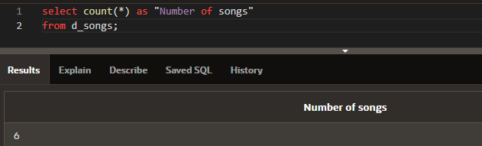

2.

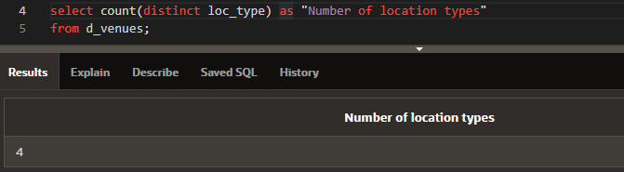

3.

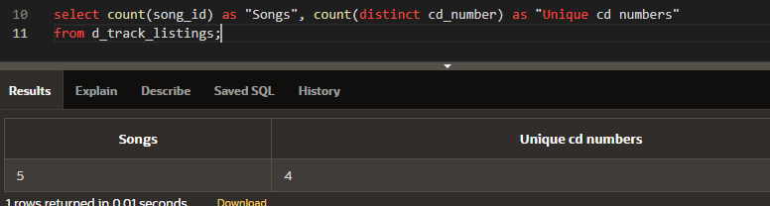

4.

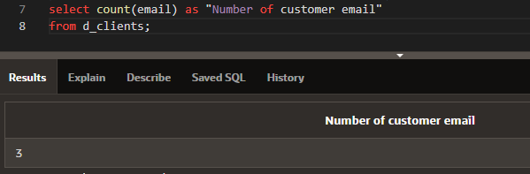

5.

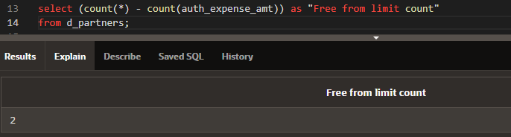

6.

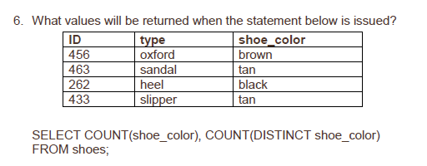

4, 3

7.

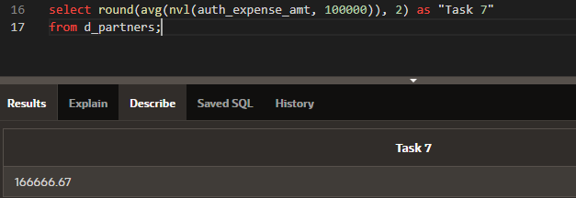

8.

__F___ a. The datatypes of the values in the NVL clause can be any datatype except date data.

__T___ b. If the selling_bonus column has a null value, 0.10 will be substituted.

__T___ c. There will be no null values in the selling_bonus column when the average is calculated.

__F___ d. This statement will cause an error. There cannot be two functions in the SELECT statement.

9.

__F___ a. Each color will appear only once in the result set.

__F___ b. Each size will appear only once in the result set.

__T___ c. Unique combinations of color and size will appear only once in the result set.

__F___ d. Each color and size combination will appear more than once in the result set.